# Product Requirements Document (PRD) for User Management System

Contents

Product Requirements Document (PRD) for User Management System 1

1.Overview 1

2.Functional Requirements 1

3.Non-Functional Requirements 1

4. Component Diagrams 2

4.1. Sequence Diagram: 2

4.2. Class Diagram 6

5. Database Schema 7

5.1 Database Design 8

6. **API Endpoints (Sample)** 8

## 1.Overview

The User Management System will allow admin and service accounts to create users, assign roles, and manage access permissions, with secure login and auditing.

## 2.Functional Requirements

1. User Registration (Admin only or via Invite)
2. Role Creation and Assignment
3. Secure Login with JWT
4. Token Refresh & Expiry
5. Logout and Session Revocation
6. Two-Factor Authentication (Optional)
7. Audit Logging (User, Role, Permission Changes)
8. Forgot Password Workflow
9. Access Control Based on Roles

## 3.Non-Functional Requirements

* Scalability to support 1M+ users
* 99.99% availability
* Token expiration handling
* Encryption of sensitive data
* RBAC that is dynamic and configurable

## 4. Component Diagrams

### 4.1. Sequence Diagram:

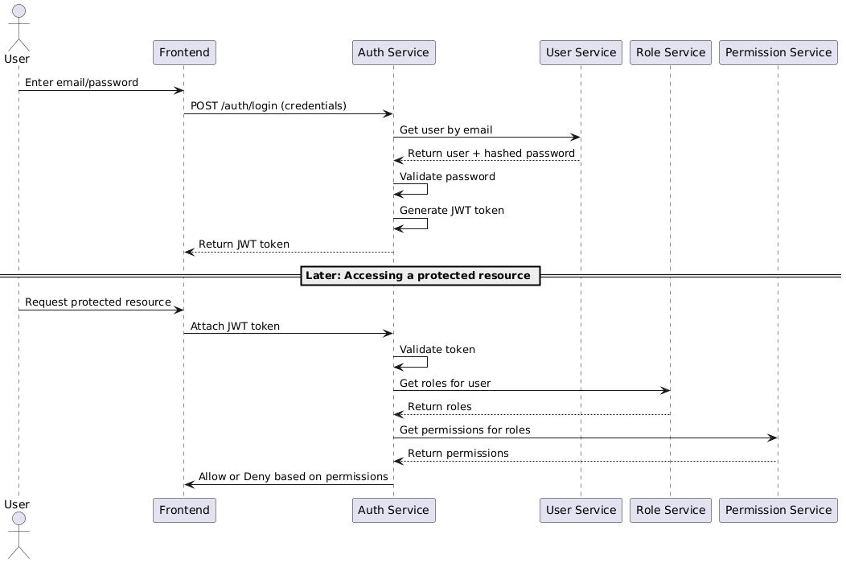

**Fig 1:** Sequence Diagram For user

#### 4.1.1 Sequence Diagram: Login and Token Flow

**Fig 1.1:** Sequence Login and Token Flow

#### 4.1.2: Sequence Diagram: Token Validation and Refresh

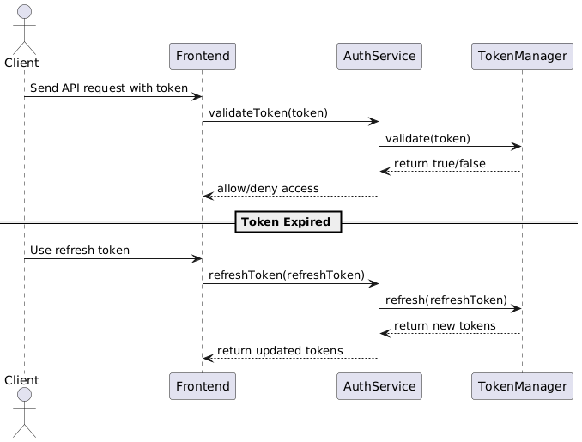

Fig 1.2: Token validation

#### 4.1.3: Expanded with 2FA and OAuth

Fig 1.3: 2Fa and OAuth2

#### 4.1.4: OAuth Login (Google/GitHub)

Fig 1.4: OAUTH Login

#### 4.1.5 Sequence Diagram: 2FA Login (TOTP)

Fig 1.5: 2FA Login Sequence Diagram

#### 4.1.6. Flow Breakdown:

* User logs in with email/password
* Auth Service checks credentials with User Service
* JWT token is issued
* On accessing a protected resource:
  + Token is verified
  + User’s roles are fetched
  + Permissions are checked
  + Access is granted or denied

### 4.2. Class Diagram

Fig 1.3: Class Diagram User Service

#### 4.2.1 User & Authentication service class diagram

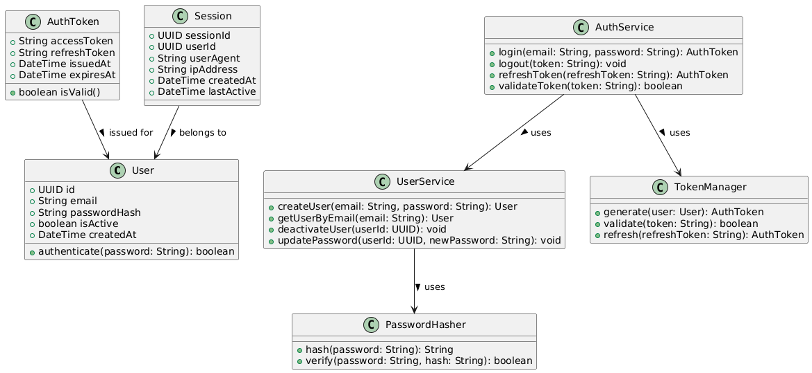

Fig 1.4: User and Authentication class diagram

## 5. Database Schema

CREATE TABLE users (

id Integer PRIMARY KEY,

first_name Varchar(100),

last_name Varchar(100),

email VARCHAR(255) UNIQUE NOT NULL,

hashed_password TEXT NOT NULL,

created_at TIMESTAMP DEFAULT CURRENT_TIMESTAMP,

is_active BOOLEAN DEFAULT TRUE

);

CREATE TABLE roles (

id Integer PRIMARY KEY,

name VARCHAR(50) UNIQUE NOT NULL,

description TEXT

);

CREATE TABLE permissions (

id Integer PRIMARY KEY,

name VARCHAR(100),

resource VARCHAR(100)

);

CREATE TABLE user_roles (

user_id Integer REFERENCES users(id),

role_id Integer REFERENCES roles(id),

PRIMARY KEY(user_id, role_id)

);

CREATE TABLE role_permissions (

role_id Integer REFERENCES roles(id),

permission_id Integer REFERENCES permissions(id),

PRIMARY KEY(role_id, permission_id)

);

### 5.1 Database Design

## 6. **API Endpoints (Sample)**

| **Endpoint** | **Method** | **Auth** | **Description** |
| --- | --- | --- | --- |
| /auth/login | POST | ❌ | Login with email/password |
| /auth/logout | POST | ✅ | Invalidate current token |
| /userall | GET | ✅ | List all users (Admin only) |
| /users | POST | ✅ | Create user (Admin only) |
| /roles | POST | ✅ | Create new role |
| /roles/assign | POST | ✅ | Assign role to user |
| /permissions | POST | ✅ | Define new permissions |
| /access-check | POST | ✅ | Check if user has permission |

|  |  |  |
| --- | --- | --- |
| Kaushik Nandy | 30-07-2025 | V 1.0 |
|  |  |  |
|  |  |  |